Articles

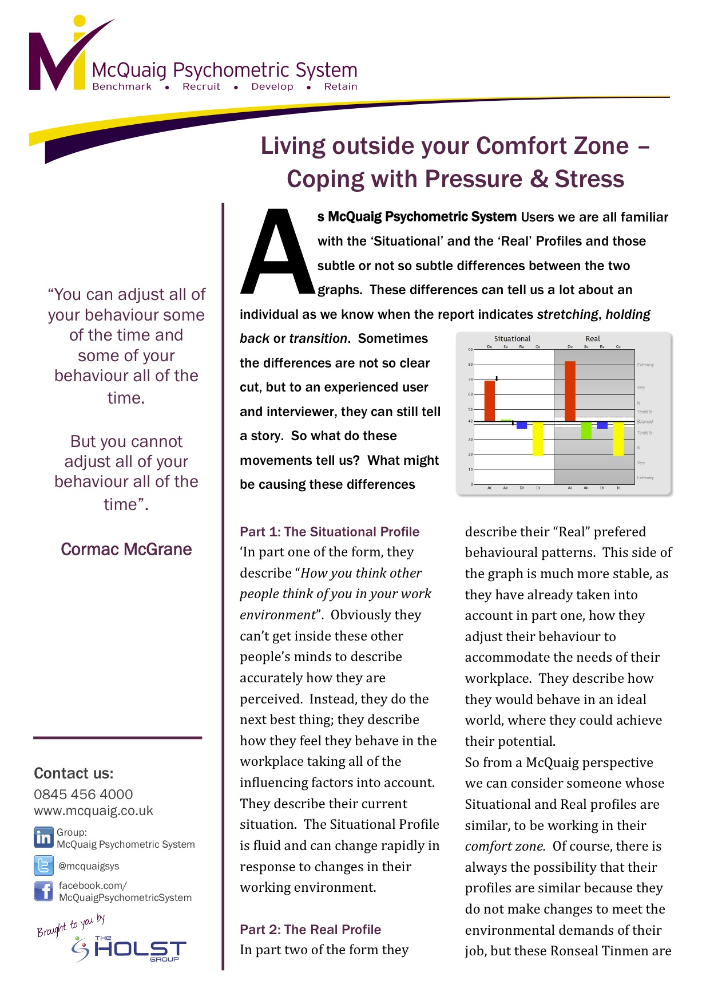Living outside your comfort zone

Championship Material with
the McQuaig Psychometric System

Choosing Wisely with
the McQuaig Psychometric System
(Hotelier Magazine)

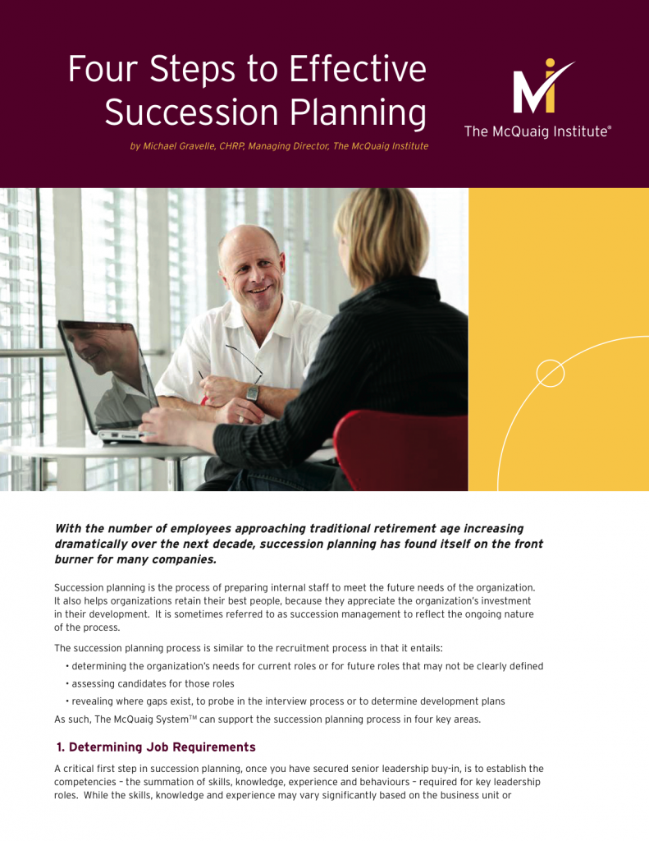 Four Steps to Effective Succession Planning

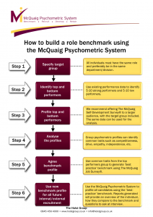 How to benchmark a role with
the McQuaig Psychometric System

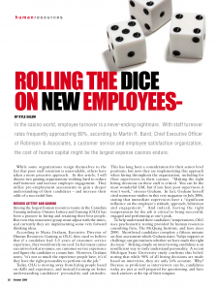Rolling the Dice on New Employees –
the McQuaig Psychometric System

Search for a Star –
the McQuaig Psychometric System

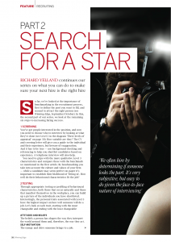 Search for a Star (Part 2) –
the McQuaig Psychometric System

Search for a Star (Part 3) –
the McQuaig Psychometric System

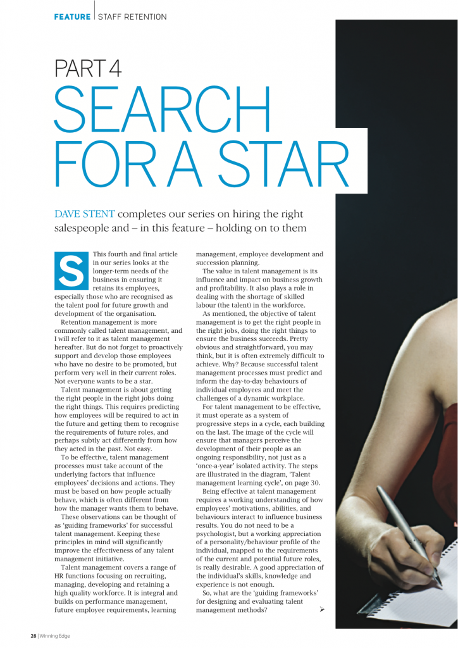 Search for a Star (Part 4) –
the McQuaig Psychometric System

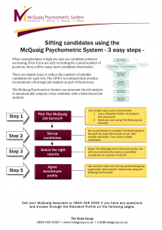 Sifting candidates –
McQuaig Psychometric System Helpsheet

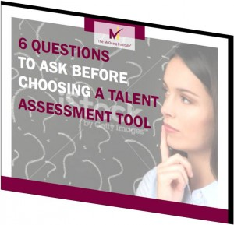 6 Questions to Ask Before Choosing a Talent Assessment Tool

Millennials: the future of our workplace

The Five Most Common Hiring Mistakes

How to Tell Your True Leadership Story

Adding Value to Executive Search

Recruiting Collection eBook

The Ultimate Guide to Effective Sales Hiring

